Project Documentation

CookBook:your virtual kitchen Assistant
1.Introduction

✓ Project title:CookBook:your Virtual kitchen Assistant

❖ Team ID:NM2025TMID31557 ❖ Team Leader:
➢ NAME:DHARSHINI R
MAIL ID: ravikumardharshini6@gmail.com
❖ Team Members
- NAME: TAMILARASI K
MAIL ID: tamilarasikanagaraj934@gmail.com
- NAME: DHARSHINI R
MAIL ID: dharshiniravi207@gmail.com
- NAME: LATCHANA S
MAIL ID: Latchanasaravanan3@gmail.com

2. Project Overview
❖ Purpose: Cook book :Your virtual kitchen Assistant empowers professionals and organisational to navigate emerging trends, share real time insights , and adapt to evolving business landscape through collaborative learning, analysis and communication ❖ Features: ➢ Cook book
- Secure chat system
- Feedback and review system
- Admin control panel
3. Architecture
❖ Frontend: React.js with Bootstrap and Material UI

4. Setup Instructions
❖ Prerequisites:
- Node.js
- Git
- React.js
- Express.js – Visual Studio Code ❖ Installation Steps: # Clone the repository git clone # Install client dependencies cd client npm install
# Install server dependencies cd
../server npm install

5. Folder Structure
SB-Works/
|-- client/ # React frontend
|__components/
L__ pages/
|__ server/ # Node.js 6.

Running the Application
❖ Frontend:
- cd client
- npm start
❖ Access: Visit http://localhost:3000

7. API Documentation
❖ User:

- /api/user/register • /api/user/login ❖ Projects:
- /api/projects/create
- /api/projects/:id • Applications: /api/apply ❖ Chats:
- /api/chat/send
- /api/chat/:userId

8. Authentication
- JWT-based authentication for secure login
- Middleware protects private routes

9. User Interface
- Landing Page
- Freelancer Dashboard
- Admin Panel
- Project Details Page

10. Testing
- Manual testing during milestones
- Tools: Postman, Chrome Dev Tools

11. Screenshots
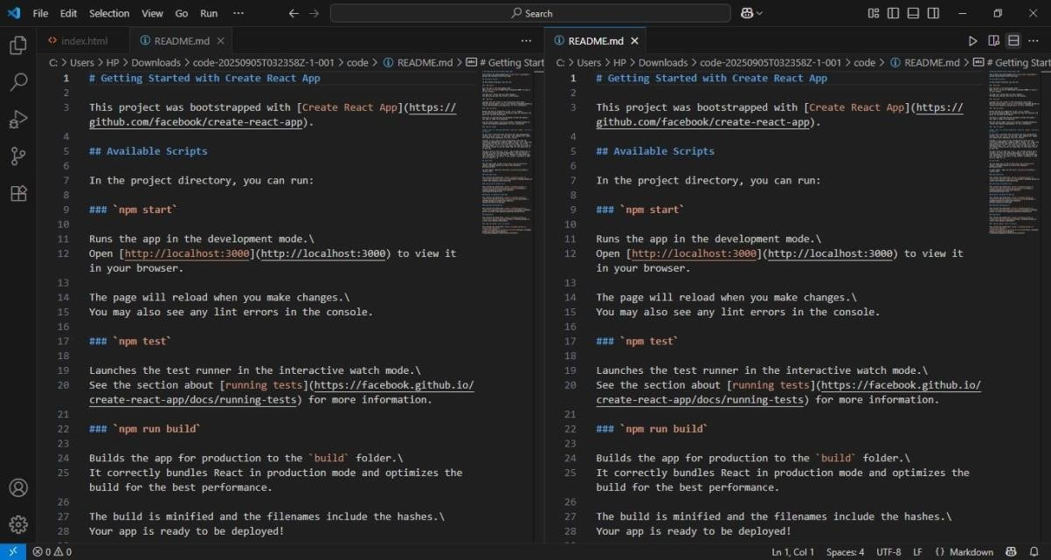
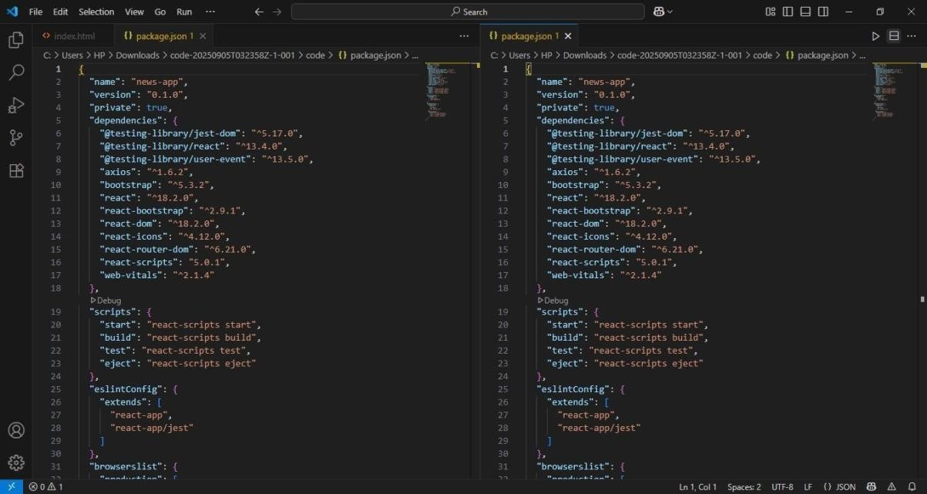
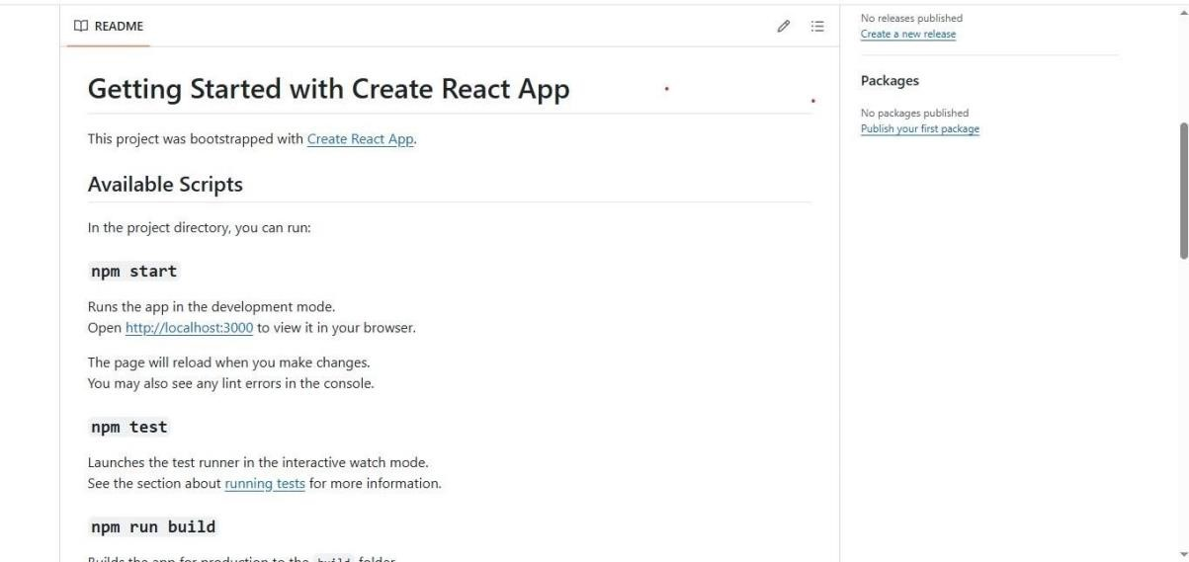
- Known Issues
  - API Rate Limits
  - Server Problem
  - Navigation Glitches
- Future Enhancements
  - Analytics Dashboard
  - Search Functionality
  - User Authentication

